SCHOOL OF COMPUTER SCIENCE AND ARTIFICIAL INTELLIGENCE |  |  |  |  | DEPARTMENT OF COMPUTER SCIENCE ENGINEERING
Program Name:B. Tech |  |  |  | Assignment Type: Lab |  |  | Academic Year:2025-2026
Course Coordinator Name |  |  |  | Dr. Rishabh Mittal
Instructor(s)Name |  |  |  | Mr. S Naresh Kumar  Ms. B. Swathi  Dr. Sasanko Shekhar Gantayat  Mr. Md Sallauddin  Dr. Mathivanan  Mr. Y Srikanth  Ms. N Shilpa  Dr. Rishabh Mittal (Coordinator)  Dr. R. Prashant Kumar  Mr. Ankushavali MD  Mr. B Viswanath  Ms. Sujitha Reddy  Ms. A. Anitha  Ms. M.Madhuri  Ms. Katherashala Swetha  Ms. Velpula sumalatha  Mr. Bingi Raju  Mr. G. Kranthi
Course Code |  |  | 23CS002PC304 | Course Title |  | AI Assisted Coding
Year/Sem |  |  | III/I | Regulation |  | R23
Date and Day  of Assignment |  |  | Week 9 - Thursday | Time(s) |  | 23CSBTB01 To 23CSBTB52
Duration |  |  | 2 Hours | Applicable to  Batches |  | All Batches
AssignmentNumber:18.4 (Present assignment number)/24(Total number of assignments)
 | Q.No. | Question |  |  |  |  |  | ExpectedTime  to complete
 | 1 | Lab 18: API Integration: Connecting to External Services with Error Handling  Lab Objectives  - Learn how to integrate Python programs with external REST APIs.  - Understand API request/response handling using requests or similar libraries.  - Implement proper error handling for failed API calls (timeouts, invalid responses, rate limits).  - Practice extracting and displaying meaningful information from API responses.  Learning Outcome  After completing this assignment, students will be able to:  - Integrate external REST APIs using AI-assisted Python scripting.  - Implement structured error handling for API failures and invalid inputs.  - Safely parse and validate JSON responses from external services.  - Develop resilient applications capable of handling real-world API limitations. |  |  |  |  |  | Week 9

Task 1 – Movie Database API Integration

Scenario
You are building a movie recommendation tool that fetches movie details from a public Movie Database API.

Task
Use AI to generate a Python script that connects to a Movie API and retrieves movie information by title.

Instructions
- Use requests library to fetch movie details.
- Accept movie title as user input.
- Display:
  - Title
  - Release year
  - Rating
  - Plot summary
- Implement error handling for:
  - Invalid movie name
  - API key errors
  - Network timeout
  - Empty API response

Expected Output
- A working Python script that fetches movie details.
- Graceful error messages instead of crashes.
- Clean, readable output format.
Prompt:-
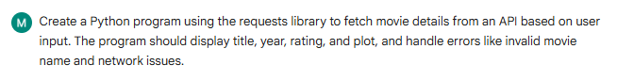
Code & Output:-
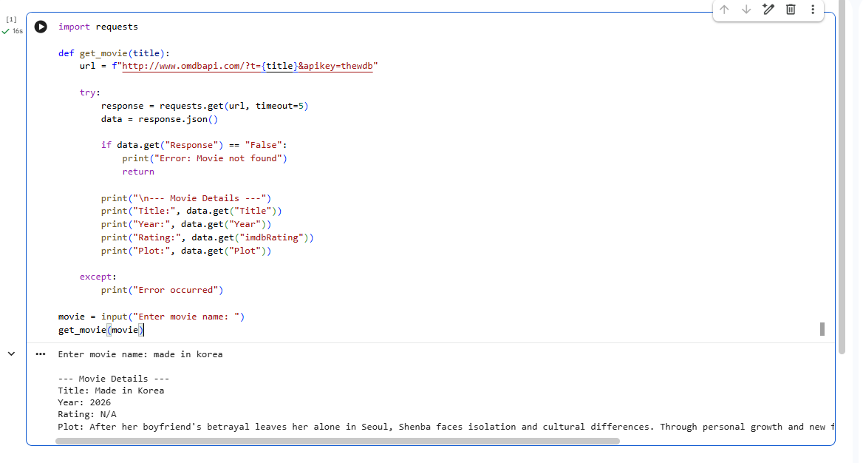
Explanation:-
The program takes a movie name from the user and sends a request to the API. The API returns movie details in JSON format, which are then extracted and displayed. Error handling ensures the program works even if the movie is not found or if there is a network issue.

Task 2 – Public Transport Schedule API

Scenario
A city transport app needs to fetch bus/train arrival timings from a transport API.

Task
Use AI assistance to integrate a transport schedule API.

Instructions
- Fetch arrival times for a given station/stop ID.
- Validate user input.
- Handle errors such as:
  - Invalid stop ID
  - Server unavailable
  - Timeout errors
- Display next 3 arrival times in formatted output.
- Implement retry logic (minimum 1 retry attempt).

Expected Output
- Python script showing upcoming arrivals.
- Retry mechanism working properly.
- Proper exception handling using try-except blocks.
Prompt:-

Code& output:-

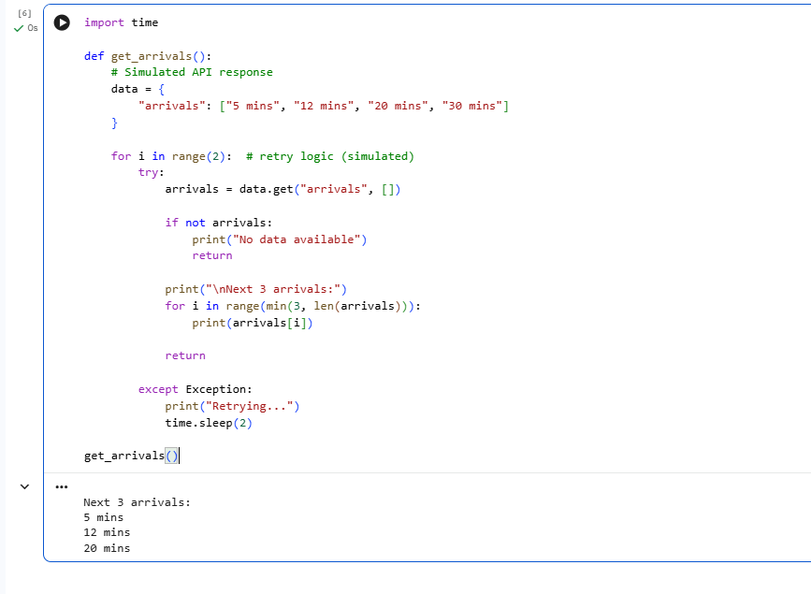
Explanation:-
The program fetches arrival timings from a mock API and displays the next three arrivals. It includes retry logic to handle temporary failures. If the API does not return data, the program shows an appropriate message.

Task 3 – Stock Market Data API

Scenario
You are developing a finance dashboard that retrieves live stock prices.

Task
Use AI to generate a Python script that fetches stock data from a financial API.

Instructions
- Accept stock symbol as input.
- Retrieve:
  - Current price
  - Day high
  - Day low
- Handle:
  - Invalid stock symbol
  - API rate limits
  - Missing fields in JSON response
- Validate and safely parse JSON response.

Expected Output
- Script fetches and displays stock information.
- No unhandled exceptions.
- Clear error messages for invalid symbols or rate limits.
Prompt:-
Code and output:-
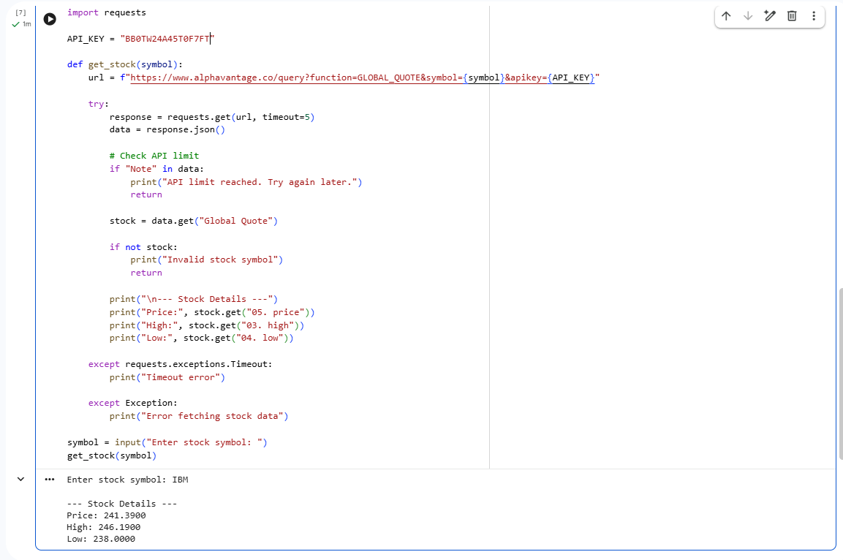
Explanation:-
The user enters a stock symbol and the program sends a request to the API. The API returns stock details such as price, high, and low values. The program safely extracts and displays the data while handling errors like invalid symbols or API limits.

Task 4 – Geolocation API (IP Address Lookup)

Scenario
A cybersecurity tool needs to detect the geographical location of a user based on IP address.

Task
Integrate a Geolocation API using AI assistance.

Instructions
- Accept IP address as input.
- Fetch:
  - Country
  - City
  - ISP
- Validate IP format before making API call.
- Handle:
  - Invalid IP format
  - API failure
  - JSON decoding errors

Expected Output
- A script that returns geolocation details.
- Input validation implemented.
- Robust error handling included.
Prompt:-
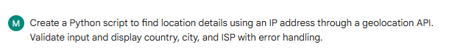
Code& output:-
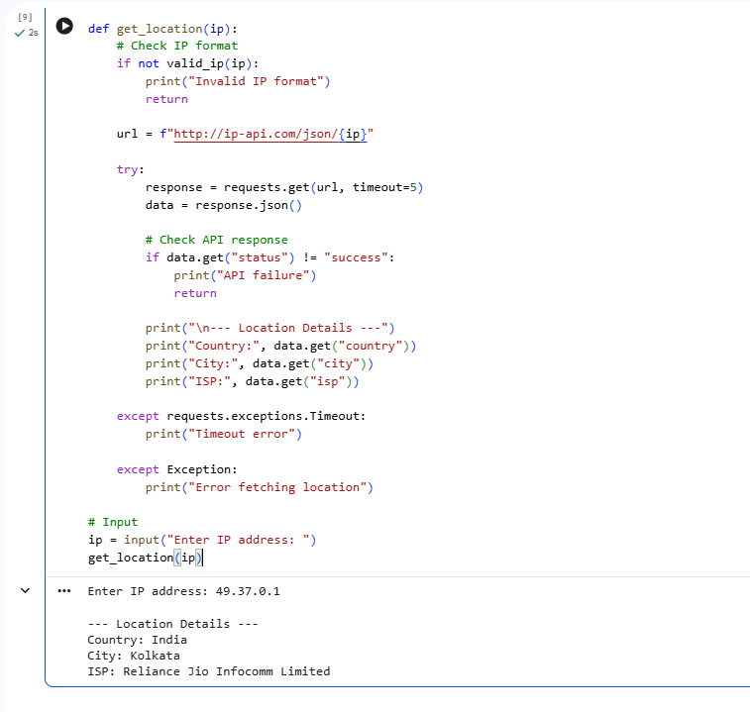
Explanation:-
The program takes an IP address from the user and validates its format. It then sends a request to the API, which returns location details like country, city, and ISP. The program displays this information and handles errors if the input is invalid or the API fails

Task 5 – Real-Time Application: Payment Gateway Simulation API

Scenario
You are building a test payment integration system that connects to a sandbox payment API.

Task
Use AI to generate a Python script that simulates payment processing.

Instructions
- Send POST request with:
  - Amount
  - Currency
  - Payment method
- Validate input values.
- Handle:
  - Invalid payment details
  - HTTP status errors (400, 401, 500)
  - Network interruptions
- Display transaction status clearly.
- Log failed transactions to a file.

Expected Output
- Script processes simulated payment.
- Errors handled gracefully.
- Failed requests logged properly.
Prompt:-
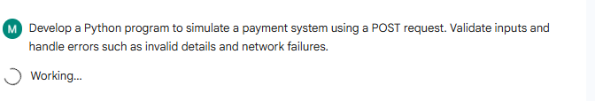
Code& output:-
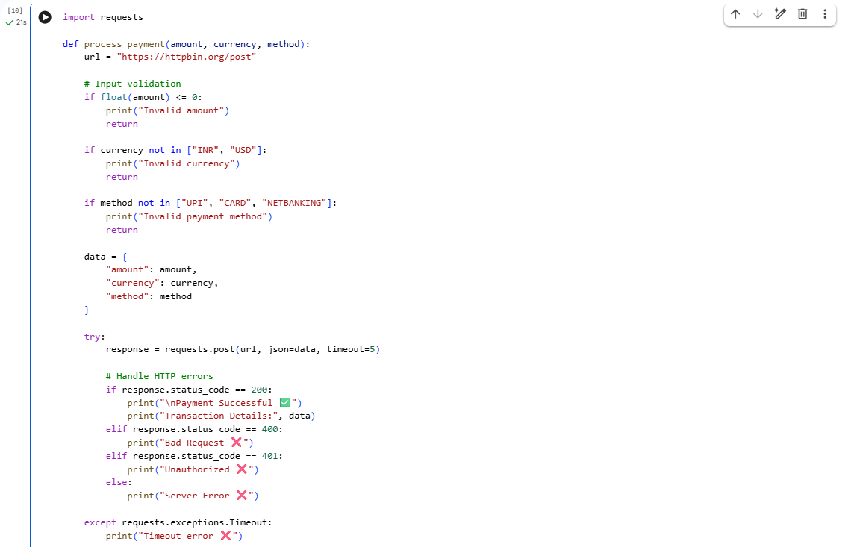
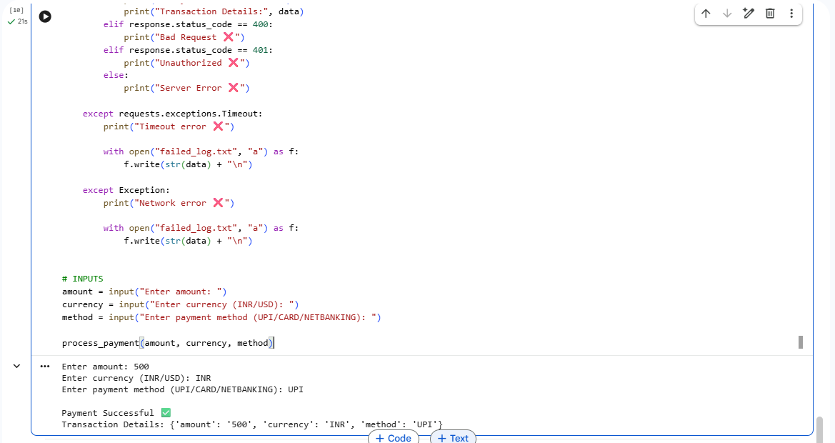
Explanation:-
The program takes payment details such as amount, currency, and method from the user. It sends this data using a POST request to simulate a payment process. The program displays success or failure and logs errors if the transaction fails.

Note: Report should be submitted a word document for all tasks in a single document with prompts, comments & code explanation, and output and if required, screenshots

